**SUBJECT: FINAL REPRORT OF THE PROJECT FOR HYGIENE, SANITATION AND WATER FOR THE COMMUNITY OF MOLI TOKURO BOMA PAGERI PAYAM MAGWI COUNTY EASTERN EQUATORIA STATE.**

**BACKGROUND OF THE PROJECT AREA**

Moli Tokuro Boma is located between Kit one and Kerapi, it is 87miles away from Juba- Nimule high way in Eastern Equatoria// State.

According to the estimated statistics gathered in late 2010, Moli Boma has an estimated population of 7648, while the primary school has population of 768 pupils, but now it was confirmed that 37731 people (women, man and children) are part of the beneficiary of this project implemented

The population rised due to the repatriation exercise process from both northern Sudan and northern Uganda.

Moli Tokuro bome have only one primary school, one small Health unit which is supported by few private clinics that only give first aid in order to deliver health services to this big population.

## PROJECT OBJECTIVES

The Project Aims to help the Moli Boma population and the school pupils by

1. conducting hygiene and sanitation training for community and school pupils
2. Drilling of 07 water points to serve the population 7,648 by then and construction of 10 door pit latrine to serve the population of 768 pupils
3. Installation of the 07 water points with hand pumps.

This Program will benefit the targeted population of Moli Boma and pupils in Moli Primary school, especially the vulnerable group (women and young girls), pupils with physical disabilities in the school.

The local authorities will participate in the planning and implementation of the whole process. The beneficiary community and the school will be involved through meetings that will be held for the allocation of the water points and the sanitary facility.

On the 18th March 2014, community Action Water Programme official visited Moli primary school and the Boma chief for the final arrangement of the project activities. The community development officer conducts the mobilization of water, committee, while the school authority did selection of pupils for Hygiene and sanitation promotion.

## **Project activities accomplished**

1. Conducted assessment in the area
2. Three meetings with community were done for the allocation of the water points.
3. Geophysics’ survey of the seven sites for the water points done. Details are in the survey report submitted
4. Mobilization, sensitization of water committees in Moli Primary school and the community of Moli Boma done.
5. Formation of 56 water supply and Hygiene promoter committees done.
6. Training of 56 hygiene promoters
7. Construction of two stance pit latrines for Moli Tokuro primary school done. Details are in the construction report submitted.
8. Drilling of the seven water points done successful
9. Installation of the seven water points with hand pump.
10. Verification of the project implemented by external auditor done

# Success

* Hygiene and sanitation training for Moli Tokuro primary school was accomplished successfully. Reports were submitted to both Embassy and state office.
* Community training of water source and sanitation committee (wssc) successfully done.
* Pump mechanic training for the seven village water points successfully done.
* Construction of Moli Tokuro primary school pit latrine two blocks with five stances successfully accomplished, certificate of completion was signed by the three partners during the ceremony.
* Handover ceremony of the facility to the school administration was successfully done with the witness of delegates from the Embassy of Japan, Government representatives, community leaders, school management committees, school administration and the pupils at large. See the below photos reflecting the project activities done in Moli Tokuro primary school and community of Moli Boma

Pupil workshop see below photo

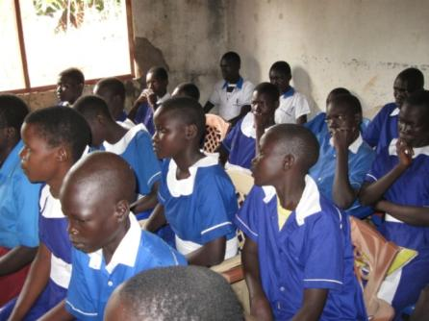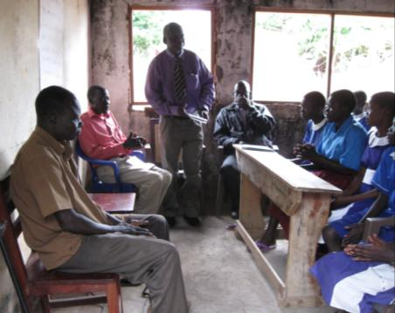

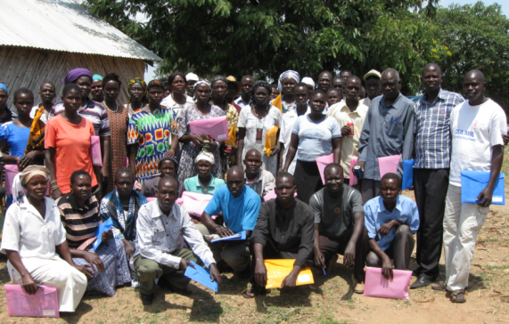

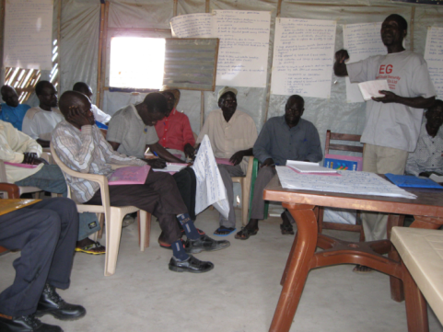Closing of the workshop of the community by boma Chief of Moli Tokuro Boma

The first drilling started at Moli Tokuro Primary school compound and was successful drilled.

The below photos showing drilling activities at Moli Tokuro primary school.

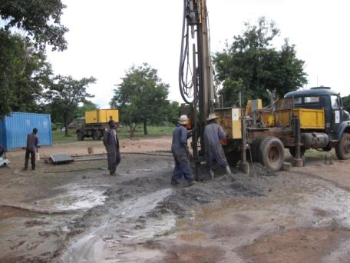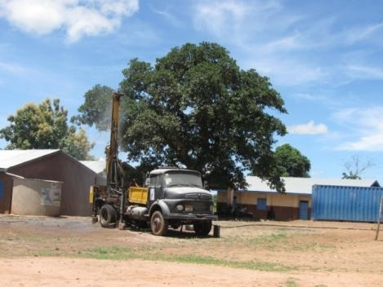

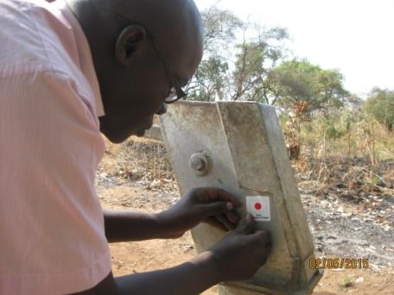

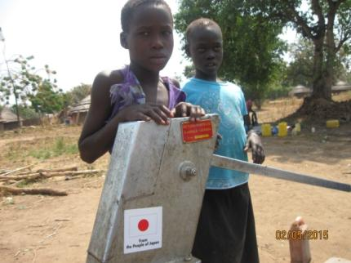

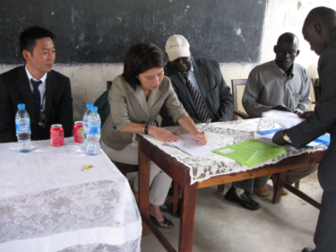

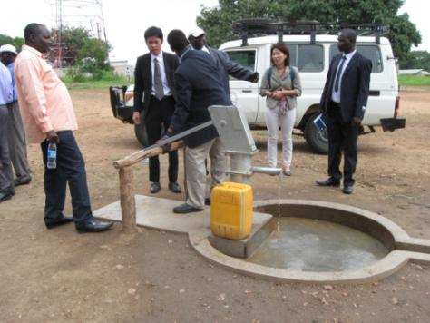Handing over ceremony at Moli primary school for the two latrine block constructed by CAWP

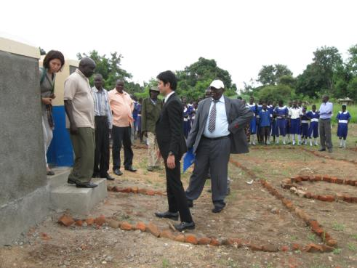

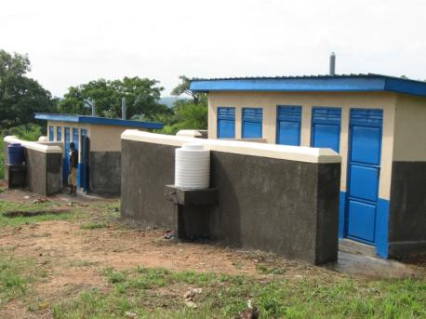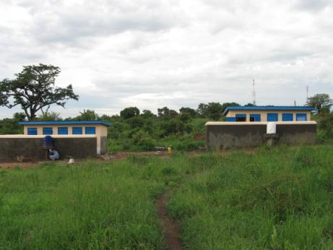The two latrine blocks for Moli Tokuro primary school

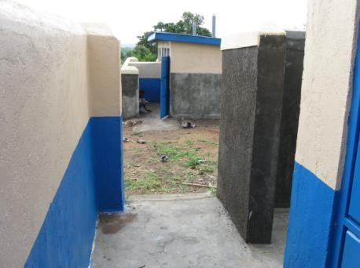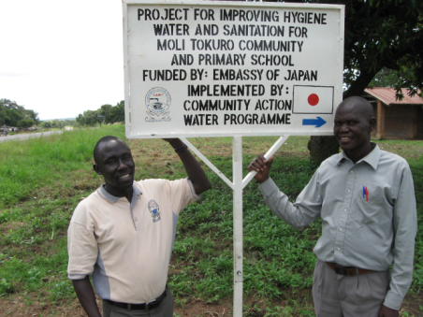

**SUCCESS:**

The success of the project for improving Hygiene water and sanitation for Moli Tokuro Community and Primary School was achieved due to:-

* Timely approval of fund requisition for activity to kick off.
* Accessibility of good road to the project site, easy transportation of construction materials to the site
* Availability of the laborers in the area to reinforce the work.
* Good cooperation between the school administration, local authority with Community Action Water Progrramme management.
* Availability of store for keeping the construction materials
* Dedicated, transparent and hard working staff
* Stability of security in the area
* Supervision and monitoring of the project by the CAWP management and the beneficiary community
* Present of the Project manager in the field

**CHALLENGES:**

* The biggest challenge the organization encountered during the implementation of the project was the sudden dead of the Hydrologist who sited the seven boreholes and after which on their way to Uganda he was involved in a car accident that claimed his life.
* Transportation of the local materials and labors went high as such CAWP had to incurred some expense.
* Heavy rainfalls experienced last year have interfered with project implementation as mentioned in the last report.
* The economic challenge the country face have affected the inflation ration on the market prices
* The dry well accounted was not budgeted for.
* Bank charges during fund withdrawing have gone beyond expectation as expressed in audit report.
* The seven drilled boreholes have not fully addressed the problem faced by the community in water shortage due to the increased population to 37731.
* Moli Tokuro primary school has a bigger number of pupils, some of the classes are still learning under the tress because of no enough classrooms which is a risk to environmental sanitation and the health of the pupils.
* The two blocks of sanitary facilities are not enough for population of 768 – 900 more pupils expected to join school this year.
* Moli Tokuro primary school kitchen where the cooking for the entire school is be done need to be upgraded to fit into the required standard of good hygiene and sanitation practices.